Task 1: Food Category Listing API
Build a read-only DRF endpoint that returns a list of all food categories as a JSON response
Create a Category model with name (CharField, max 100) and description (TextField) fields and run migrations.
Write a CategorySerializer using ModelSerializer that exposes id, name, and description.
Create a ListAPIView endpoint mapped to /api/categories/ and register it in urls.py.
Return all categories as a JSON array with HTTP 200; test the response in Postman or the DRF browsable API.

Ans=
1
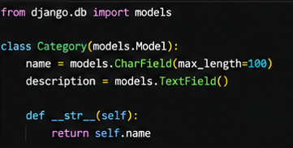
2
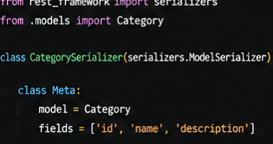
3
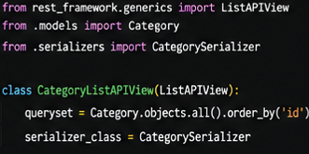
4
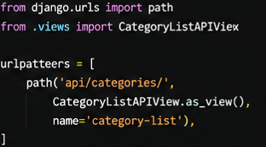
5
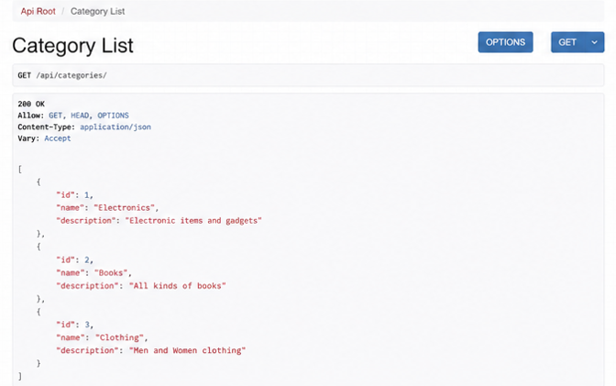

Task 2: Menu Item CRUD API
1Create a MenuItem model with name, price (DecimalField), category (ForeignKey to Category), and is_available (BooleanField) fields.
2 Write a MenuItemSerializer using ModelSerializer that validates price is greater than 0 and raises a ValidationError if not.
3Implement list (GET), create (POST), retrieve (GET /id/), update (PUT /id/), and delete (DELETE /id/) endpoints using APIView or GenericAPIView.
4Return HTTP 201 for successful creation, 400 for validation failures, and 404 when the item is not found.
Ans=
1
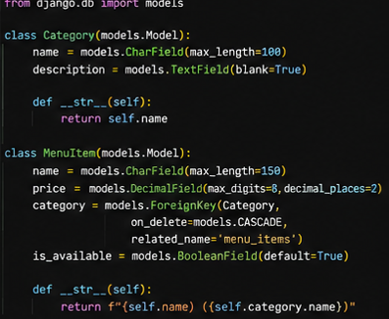
2
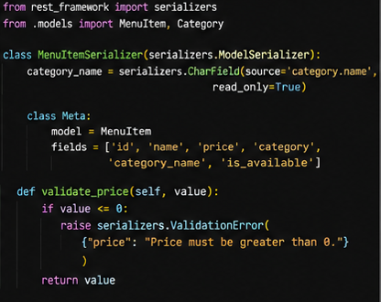
3
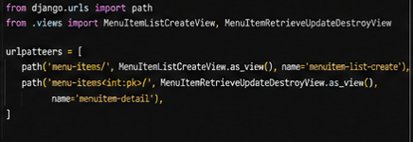
4

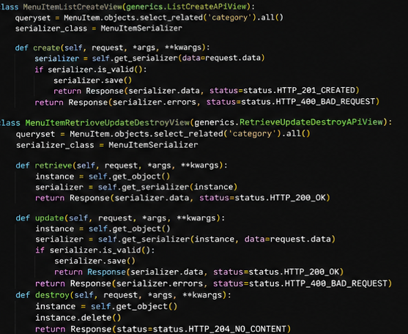
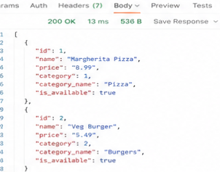
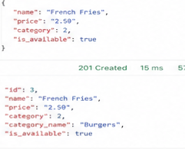
Task 3: Order Listing with ViewSets, Router, and Pagination
1Create an Order model with customer_name, item (CharField), quantity (IntegerField), and status (CharField with choices: pending, confirmed, delivered) fields.
2Convert the Order API to a ModelViewSet and register it with a DefaultRouter — the router must auto-generate all CRUD URLs under /api/orders/.
3 Configure PageNumberPagination in settings.py with PAGE_SIZE = 5 and apply it to the Order ViewSet.
4Support filtering orders by status using a query parameter (e.g. /api/orders/?status=pending) using the get_queryset method.

Ans=
1
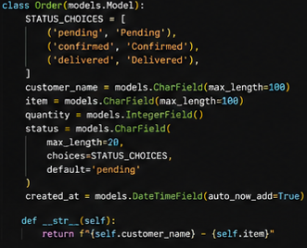
2
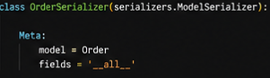
3
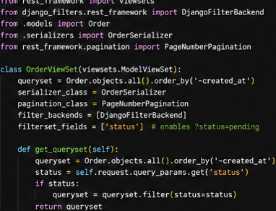
4
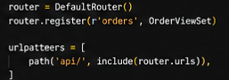
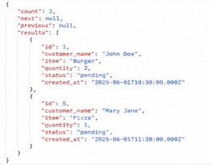
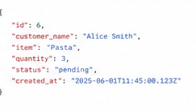

Task 4: Token-Authenticated Order Placement
1Enable DRF TokenAuthentication in settings.py and generate auth tokens for test users via the Django shell or admin.
2Create a PlaceOrderAPIView (POST /api/my-orders/) that uses IsAuthenticated permission and saves the request.user as the order owner.
3Add a GET /api/my-orders/ view that returns only the orders belonging to the currently authenticated user, filtered by request.user.
4Return HTTP 401 Unauthorized (with a meaningful message) for any unauthenticated request to either endpoint.
Ans=
1
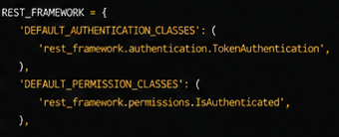
2

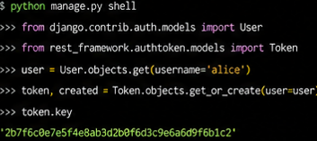
3
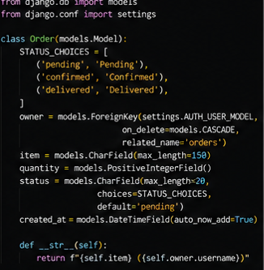
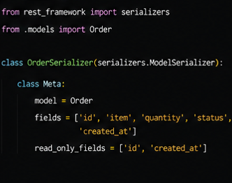
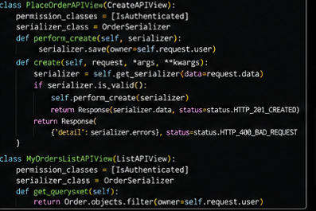
4
